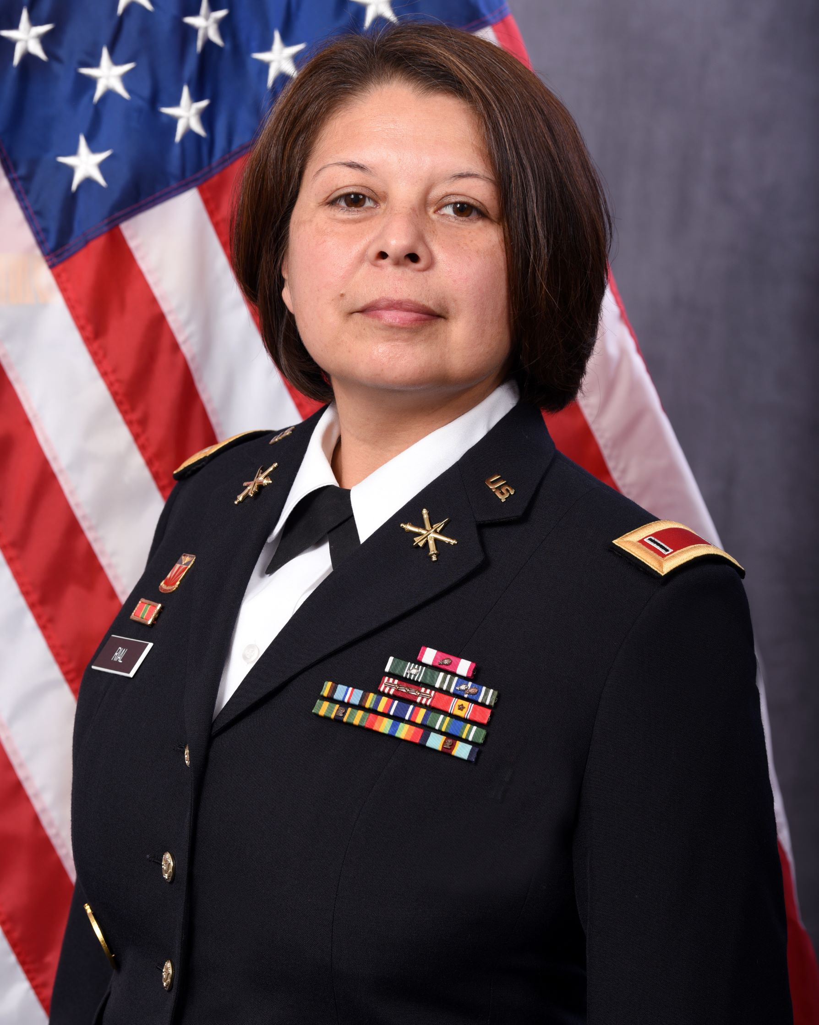

Chief Warrant Officer 5 Araceli R. Rial assumed duties as the Command Chief Warrant Officer for 10th  Army Air Missile Defense Command (AAMDC) in March 2023.

CW5 Rial began her military career in the United States Army in 1994 as a Patriot Missile Crewmember (MOS 16T) with 2-7 ADA BN, Fort Bliss. In 2005, she received her Warrant Officer appointment as an Air & Missile Defense System Technician (MOS 140E). She has held various positions all over the world such as Battery Maintenance Technician, Tactical Director, Battalion Readiness Officer, Support Operations Officer, and Air Defense Branch Maintenance Officer at locations that include South Korea, Germany, Fort Bliss, Fort Bragg, Fort Sill, and Redstone Arsenal. Her most recent assignment, CW5 Rial was the assigned to the 10th AAMDC G4 and the Senior AMD Technician.

Her military education includes the Warrant Officer Senior Service Education Course; Warrant Officer Intermediate Level Education; Warrant Officer Advance Course; Contractor Officer Representative Course; SHARP Certification Course, and US Army Drill Sergeant Course.

Her award and decorations include the Legion of Merit; Meritorious Service Medal (2OLC); Army Commendation Medal (1SOLC); Army Achievement Medal (1SOLC, 1OLC); Army Superior Unit Award; National Defense Service Medal; Armed Forces Expeditionary Medal, Global War on Terrorism Service Medal; Korea Defense Medal; and Army Drill Sergeant Identification Badge. She is the recipient of the Ordnance Order of Samuel Sharpe, the Honorable Order of Saint Barbara, and Ancient Order of Saint Barbara.

She holds a Bachelor of Science degree in Social Psychology from Park University and a Master of Education in Organizational Leadership and Adult Learning.

CW5 Rial is married to Jordan of York, Pennsylvania; they have two children.